**Mobile application based on unity 3D**

by

Guoquan Wang, Terry

(1430003024)

A Final Year Project Thesis (COMP4004; 3 Credits)

submitted in partial fulfillment of the requirements

for the degree of

Bachelor of Science (Honours)

in

Computer Science and Technology

at

BNU-HKBU

UNITED INTERNATIONAL COLLEGE

June, 2017

DECLARATION

I hereby declare that all the work done in this Project is of my independent effort. I also certify that I have never submitted the idea and product of this Project for academic or employment credits.

______________________

##### Guoquan Wang, Terry

##### (1430003024)

##### Date: ___________________

**BNU-HKBU**

**United International College**

Computer Science and Technology Program

##### We hereby recommend that the Project submitted by Guoquan Wang, Terry entitled " Mobile application based on unity 3D " be accepted in partial fulfillment of the requirements for the degree of Bachelor (Honours) of Science in Computer Science and Technology Program.

_________________________ _________________________

##### Date: _________________ Date: ___________________

ACKNOWLEDGEMENT

I would like to express my great gratitude towards my supervisor, **Dr. Jing Zhao, Dyce** who had given me invaluable advice to this project.

**Mobile application based on unity 3D**

by

Guoquan Wang, Terry

(1430003024)

A Final Year Project Thesis (COMP4004; 3 Credits)

submitted in partial fulfillment of the requirements

for the degree of

Bachelor of Science (Honours)

in

Computer Science and Technology

at

BNU-HKBU

UNITED INTERNATIONAL COLLEGE

June, 2017

# ABSTRACT

In this project, we created a multi-player 3D shooting game based on Unity. We provide two means for players to be connected and start a game: through an online game server or through direct connection based on TCP-IP. In the game, each player controls a tank. The goal is to aim and shoot the opponent’s tank while moving their own tank to evade bullets. Health points will be deducted if a tank receives damage and if a tank’s health points drop to zero, the other player claims victory.

There are two main scenes, one is lobby scene, which is used to connect two users, setup the game as requested by the players. The other is main game scene, which is used to play the game. Unity 3D is used as the engine of the project. With its powerful deployment platform, this project can run on computers as well as mobile phones.

.

**Contents**

ABSTRACT 6

1. Background 8

1.1 An exploration of current popular games 9

2. Related Works 13

2.1 Lara Croft GO 13

2.2 Jenny LeClue 13

2.3 Forgotten Anne 14

3. Project Specification 16

3.1 Lobby scene 17

For developer user 17

For normal user, 18

Why choose 2 different ways to connect the player? 18

3.2 Game Scene 19

3.3 Scene Setup 20

Prefabs 20

Tank prefab 21

Shell prefab 21

3.4 Tank creation and control 22

3.5 Camera control 22

3.6 Tank’s health 24

3.7 Shell creation and firing 24

How shell damage tank health? 26

How shell makes tank physic forces? 27

3.8 Joysticks 27

Movement Joystick 28

Shooting Joystick 29

3.9 Game managers & multiple-player establishment 29

References 30

Appendix 31

1. Sample code 31

2. Shell creation and firing (deleted) 33

3. Skybox (deleted) 34

# 1. Background

Unity3D is an award-winning tool for creating interactive 3D applications on multiple platforms. Unity3D is combined by game engine and the editor. The engine contains software components that are the most common and recurring tasks in game research and development. It covers the topic like sound, graphics, physical and network functions, and it supports C#, Boo, and JavaScript scripting.

The rise of mobile game to allow consumers to focus more attention on the phone. In 2013, its popularity has continued to today. Is it easy to find a job? For a commercial game engine, it is important that solute a sample and similar effect quickly and efficiently. The original intention of the game engine is to transfer the game developer's energy to the game's playability. So, the reason why Unity3D attract the developer's attention is cheap, and can be published as a browser-based web page format. This is a major trend, players do not have to download a huge client, open the browser to enter the game.

The rise of the mobile game market also makes Unity3D development personnel in a sharp shortage of state, according to unofficial statistics Unity3D talent gap has reached 800,000! Unity3D development engineers have become a new era of mobile Internet high-paying jobs, especially the game development engineers.

In recent years, the mobile game market is very competitive, the mobile game companies are required to quickly develop new games to capture the mobile game market share, a good game engine is to solve such problems in the top priority! In 2010, Unity3D game engine into people's vision, it is simple, easy to learn, flexible, has been gradually used by various types of platform manufacturers to new works, which produced global game developers, personal use Unity3D boom. In the country, according to authoritative statistics, 50% of the Unity3D developer working years in 2 years, 45% of the developer working years between 2 to 5 years, the average salary of more than RMB 11,000! [2]

We try to apply Unity3D in this mobile application project, which, as we planned, should be a mobile game. The mobile phone game is very popular in these days. From little games like Gluttonous Snakes and Backgammon, to big games like the King of Glory and the Heroes of Newerth, they can be achieved through a simple Unity3D program.

The unity official website stated that any 2D or 3D game can be created with Unity. You can make it with ease, you can make it with highly-optimization and beauty, or you can deploy it with a click to multiple platforms.

## 1.1 An exploration of current popular games

According to my current exploration of games, the common thing in the most popular games like Overwatch and League of Legends (LOL) is that many people try to achieve the same goal, such as demolishing the opposite baseors and guardding their own chariot. All of these games can be played by the mobile phone or computer. Some games like Four Army Chess do not persist long because their rules cannot be updated. The reason for the others having long life is that the internal 'heroes' are constantly updated and added. For example, up to May 4, 2017, LOL already has 133 different heroes and each hero has 5 different skills. Its operation is complex and the loaded selections are various.

There are several disadvantages of such games which cannot be fixed:

1) League of Legends has a map with three different roads (upper, middle, and down roads). Using the fastest hero to go from the base to the enemy’s tower needs 40 seconds through the middle road. The game process is very slow, and the average game time is long (35-45 minutes).

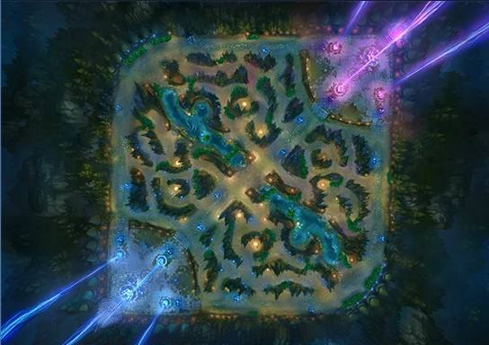

**Figure 1.1.** The map of League of Legends

2) Overwatch is a first-person shooter game produced by Blizzard Entertainment. Some people may feel dizzy when playing on it because they have motion sickness. In addition, players need to be charged 198 RMB or 328 RMB to download different versions of the game. For this expensive fee, few people are willing to play Overwatch.

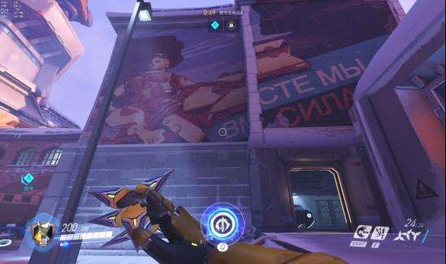

**Figure 1.2.** A Screenshot of Overwatch

3) King of Glory is a mobile competitive game that is very similar to LOL. Five persons need to form a team to compete against another team. Sometimes someone in the team does not show the spirit of teamwork and plays unsightly. This kind of players is found out to be primary school students for whom the game is not suitable.

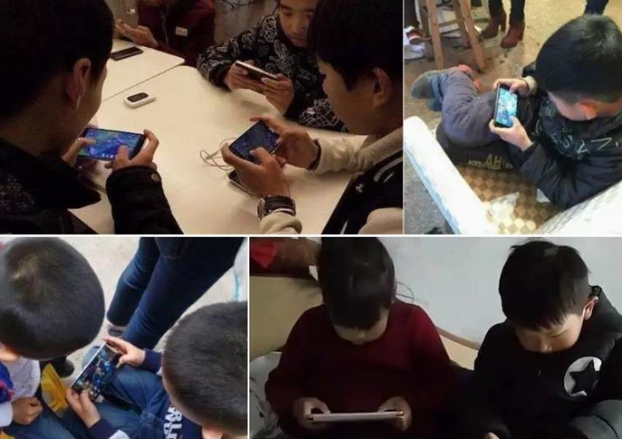

**Figure 1.3.** Too many kids play on King of glory

4) Archers fighting is a mobile game, which ask us to play an important pixel man. Player uses the virtual joystick to control pixel man. The pixel man can shoot another pixel man to get points. After the game, the player feels joyful and totally relax. However, the pixel man is hard to control and cannot aim another pixel man. Players can only aim with their feelings and does not have competing mood.

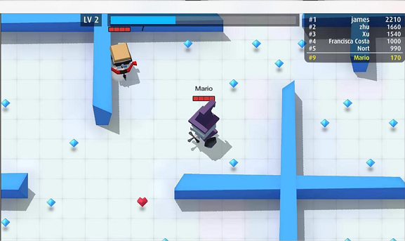

**Figure 1.4.** A Screenshot of Archers Fighting

# 2. Related Works

The following games listed are produced with unity3D.

## 2.1 Lara Croft GO

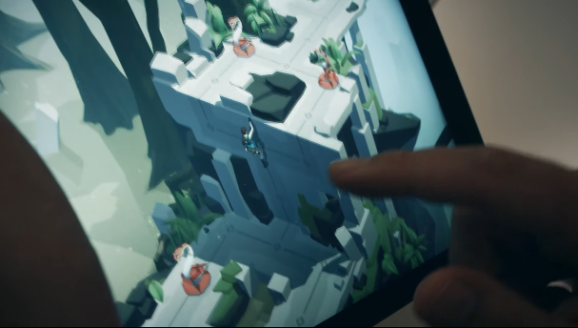 Lara Croft GO is a good game made by [Square Enix Montreal](https://madewith.unity.com/en/profiles/square-enix-montreal) using Unity3D and is adapted from the game Hitman GO [3]. It won the 2016 Apple Design Award. People have to pay 30 RMB to the Apple application store if they want to play this game. It goes from a classical beating game to a turn system game, which contains exquisite puzzle and ingenuity but without losing the character. The player needs to calculate every step he goes, thinking about where he can “recover”, and pick a good way to either forest or grave. Finally, when the python is wiped out by the player, he will feel full sense of accomplishment. There are 115 different questions on the Lara Croft Go and 7chapters. What’s more, there is free iMessage expression bag coming out after the game.

**Figure 2.1.** Player plays Lara Croft GO

## 2.2 Jenny LeClue

Jenny LeClue - Detectivús is a game made by [Mografi](https://madewith.unity.com/en/profiles/mografi) using Unity3D[4]. Player plays as a young detective Jenny LeClue, who can found interesting secrets in the game. According to the official website, Jenny LeClue is a story that drives exploration adventure with memorable characters, a unique aesthetic, and an epic tangled mystery[5].

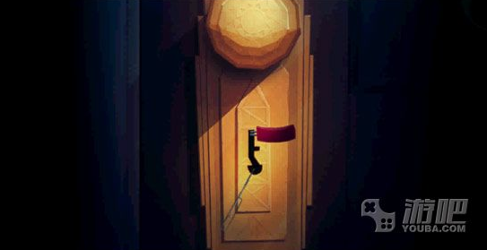 Jenny LeClue is a novel puzzle adventure game where players need to play a bold and lively Lolita, in order to be charged with the murder of the mother to lift the complaint, looking for clues alone.

**Figure 2.2.** A screenshot of Jenny LeClue

If players like to explore mature item or like to find the real killer from detail inference, they will love this game. There are more than 76,200 results by searching the Jenny LeClue in Google (2017). Not only it runs successful in mobile system, but also in Steam, plat station 4 thousand of Jenny LeClue raiders in the website.

## 2.3 Forgotten Anne

Forgotten Anne is a game made by [ThroughLine Games](https://madewith.unity.com/en/profiles/throughline-games) by Square Enix Collective system and Unity3D. The main content of Forgotten Anne is about protagonist Anne trying to get out of weird Forgotten Realms, and back to the real world. Anne begins her work when the real world with forgotten people and a variety of biological country "Forgotten Realms" on the occasion of chaos.

As the company stated, Forgotten Anne is a two-dimensional cinematic adventure game combining puzzle plat-forming with adventure game elements.

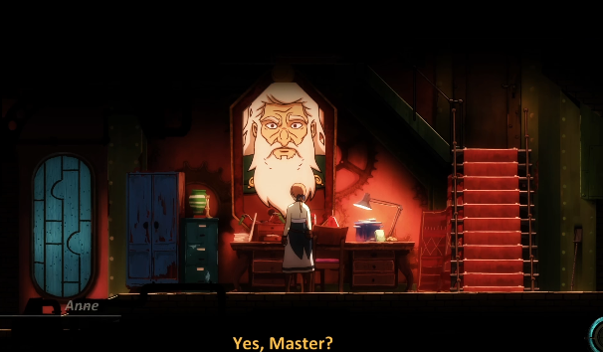

**Figure 2.3.** A screenshot of Forgotten Anne

# 3. Project Specification

Nowadays, competitive game becomes more and more popular. To unify the advantages of some competitive games. Archers fighting is the game what I want to transformation. Use unity3d to complete a game like archers fighting.But full of competing style. The most important thing is using one players compete one players game rules.To avoid the big map in the game like the disadvantage in LOL. To avoid first-person shooter game like the disadvantage in Overwatch. In addition, named the game as shooter shooting / tank shooting.

In order to make sure the different between archerfighting, set the demage following part Shell Creation& Firing. Once one team with 2 shooters are killed, the other team win the game. It also has the possibility to kill team member, may control a shooter and kill himself. Thus, the game will become full of passion and tension.

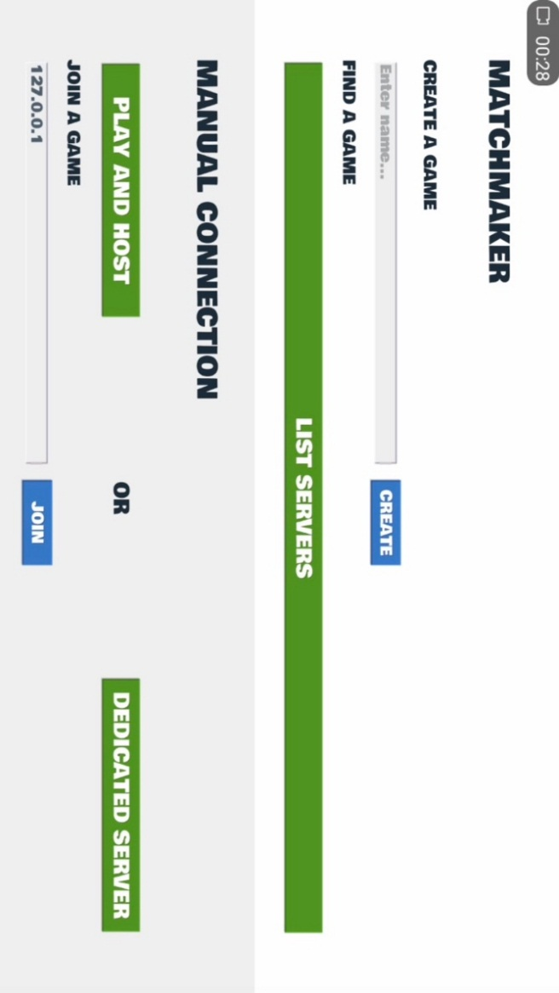 As a result, the entire game production becomes very clear.And totally different from archer fighting.

We can be a brief summary of the details to do this to subdivide.

**Figure 3.1.** A Screenshot of Main Lobby Scene

## 3.1 Lobby scene

The Tank shooting game is a multi-player game. So, the computer needs to know which two players are going to solo. This lobby can deal with the problem and ask the main game scene to generate our main character.

Before this, we have to know which is a major character and what can be generate.

the thing we need to translate from lobby scene to main game scene is where the main character prefab set for. For example, the rotation and location and what can be generated. Thus, set for a spawnable point can deal with every related networking thing. Once two players connect in the same game, this game can be played.

This project lobby scene is very powerful. There are two different ways in my project can deal with the connection.

### For developer user

It can directly link by manual connection, which is based on TCP/IP mechanism

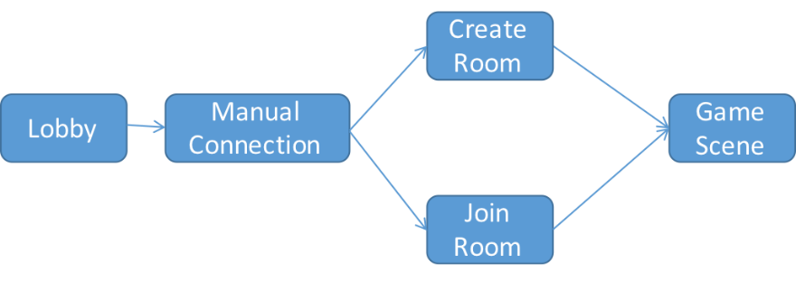protocol. When one player goes into the manual connection, it has to create a room. After the player create a room. The other player can only join the room by typing the physical address. Also, after 2 players join the room and ready for the game. Two players are going to the same game scene in the same time. In addition, player can select the name and color in the game. Once player select the color, the main character rigidbody can directly changes into selected color. Lobby scene can use round robin to let the main character spawn randomly in the spawnable point. Currently, main game scene has four different spawnable point. In case we want to add more player, we just need to add some spawnable point and set the maximum number as we wish.

**Figure 3.1.1.** A Flow of Manual Connection

### For normal user,

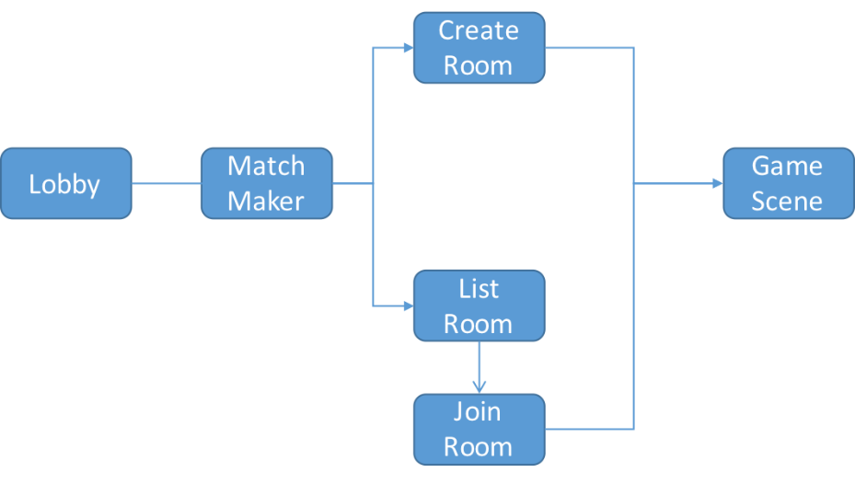The best connection is matchmaker. This connection is based on UNET mechanism protocol. When one player goes into the matchmaker, it can create a room. After the player create a room. The other player can list the room and select which room player is going to connect. After 2 players join the room and ready for the game. Two player are going to the same game scene in the same time. Also, this scene can select the color and types with the player name and room name as player wish.

**Figure 3.1.2.** A Flow of Match Maker

### Why choose 2 different ways to connect the player?

The mechanism protocol is different, matchmaker is UNET and Manual Connection is TCP/IP. In other word, manual connection is developed for developer user, matchmaker is used for normal player. If we use the matchmaker, this connection stability depends on the quality of network. If the network doesn't work well, they may have a large amount of trouble. Also, if the game optimize is not good enough, it also does not work like what we want. However, manual connection doesn't care about your network quality and optimize. It can work this game scene offline because the creating room player is the host. So, after connected, we are going to play the tank shooting game.

**Figure 3.1.3.** A Flow of Both Manual Connection and Match Maker

## 3.2 Game Scene

What we need is install Unity 5.6 or greater.

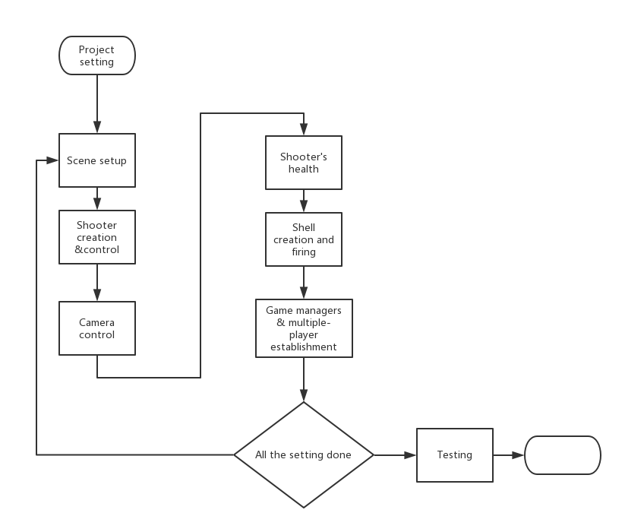New a project names Shooting Shooter. Set 2 by 3 layout on the top corner. and set every windows to where comfortable. in addition, project window should be zoom to minimum because the name of the project file name should be visible.

**Figure 3.2.** Game Scene Data Transition Diagram

## 3.3 Scene Setup

Go to File>New Scene and create a empty scene names main. After the creation the entire scene for example trees, walls, oil field, Cacti, boundaries, military, etc. most important thing, save the scene.

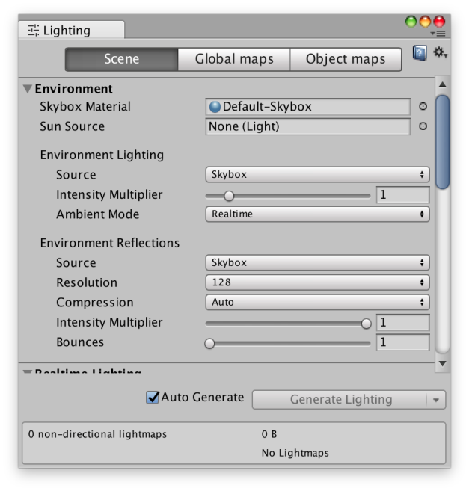

**Figure 3.3.** Creating lightning panel

In addition, directional light should be delete from the hierarchy and the scene seems much better.

Then go to Windows>lighting>settings. Unity will show this panel.

In this panel, several things to do. Uncheck the Botton realtime global illumination in Realtime Lighting. Apparently, uncheck the Auto Generate bottom at bottom of panel. Set other setting according to personal preference.

Secondly, click on Generate Lighting. Then the light will automatically generate.

Thirdly, go to scene inspector panel and set a comfortable position and rotation.

Finally, set orthographic in the camera component instead of projection, solid color instead of skybox. Once everything is done, save the scene.

### Prefabs

After we done some fussy lobby. We are going to create our major character, which is tank. Unity3d give us a chance to create major character by prefab, which is very convenient for us to develop game. For every prefabs have one or many actions, some of them has a model. Here, I am going to show the action this tank prefab has.

### Tank prefab

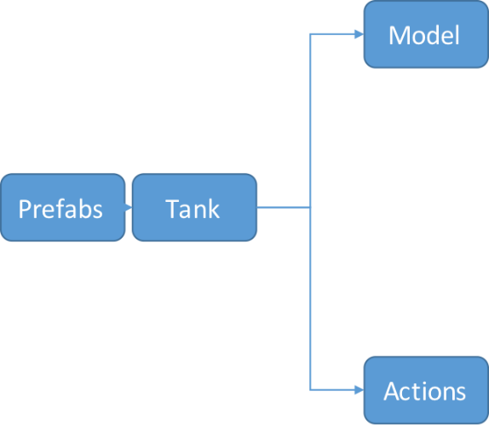At the beginning, game scene creates 2 tanks on the level art. The tank can move because I create a tankmovement.cs script drag to tank prefab. The tank can shoot because I create a tankshooting.cs script drag to tank prefab. The tank can die because I create a tankhealth.cs script drag to tank prefab.

**Figure 3.3.2-1.** Tank Prefab

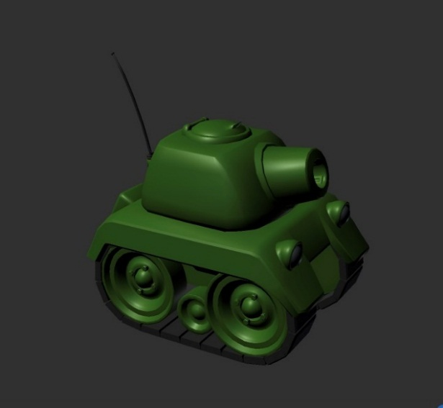

The script tells the detail how the tank does and how to generate other prefabs. For example, tank shoots have to create a new shell prefab. The shell need to know, where am I going to instantiate and where should I shoot. For other example, after the tank dies, the prefab TankExplosion has to play immediately.

**Figure 3.3.2-2.** Tank Model

### Shell prefab

After we done tank prefab, what we need to generate is shell prefab. Also, Shell prefab has a model and many actions.

**Figure 3.3.3-1.** Shell Prefab

Once player hit on fire bottom, the shell automatically instantiates from the mouse of the tank. If hit something not 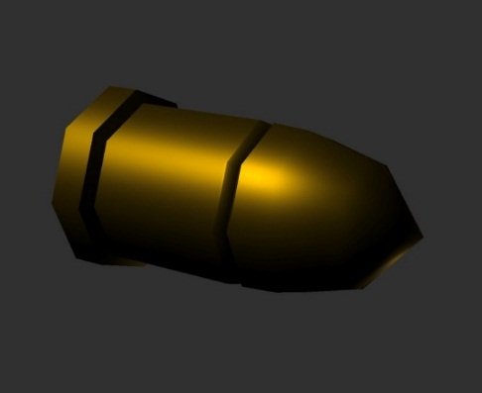related rigidbody or do not hit something, the shell will die and play the prefab ShellExplosion. If the shell Hit something related rigidbody and has a tankHealth.cs associate with rigidbody, it will calculate the damage and play a physic force to tank. Finally, shell dies and play the prefab ShellExplosion. Then one shoot is over.、

**Figure 3.3.3-2.** Shell Model

My project contains other 30 different prefabs (like tank and shell) to guarantee the mobile game to play. what you need to do is play my game and have fun.

## 3.4 Tank creation and control

The model of this game can download from the unity3d offial website. What we can do is to create a shooter/tank (or a little box instead of it) in the models folder and open it in the Hierarchy. and then the shooter/little box becomes a GameObject. In addition, change the shooter layer to Players.

It is worth mentioning that create a Rigidbody component under the shooter hierarchy can we make sure shooter only walking on the earth flat, which is select the Freeze position Y and Freeze Rotation X and Z, this is also a good way to optimize network faster. It is also a way to optimize the network manager to make the game normal in the Match Maker.

Then, use a Box Collider component to draw a shooter shape. Also, shooter shooting needs audio both on play on awake and play on “sleep”.

Finally, setup a control of the shooter.

Save the scene.

## 3.5 Camera control

At the begining, what we need to generate is a this monobehavior version of camera control. Once the version has finish, it can easily change into a net version and directly use it.

There is a empty GameObject in the Hierarchy panel. Create an empty and rename it as Camera. Select a good position on the shooter icon and rotate is as comfortable as we see. Also, we can create a main camera

and using it in the Hierarchy panel. Position and Rotation need to pick.

Because we use a mobile to play this game. So, we can generate a size to zoom. Where size we can setting it by ourself.

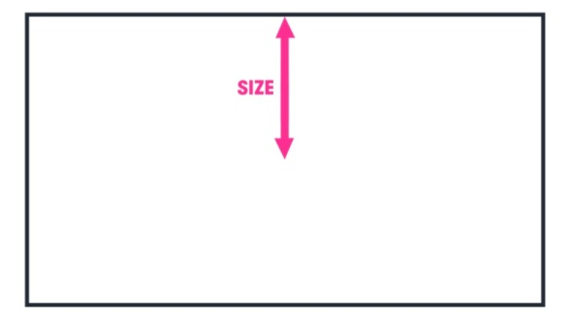

**Figure 3.5-1.** Zoom size

In addition,a large number mobile phone screen is 1080p. so we choose 1080p as our screen size. which means screen is 1920*1080. so, the aspect should be 16/9.

Finally, we just need to ask the camera to follow our shooter. Zoom with different condition where 4 players in the same screen.

In order to make sure every shooter in the screen, camera control prefab should find the average of two or more shooters position. Finally, deal with every detail. Save the camera as a prefab.

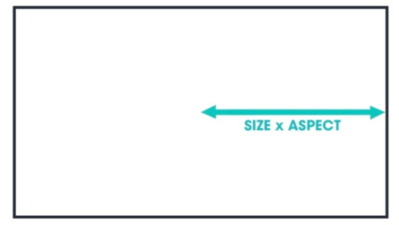

**Figure 3.5-2. Size $×$** **Aspect**

This camera can use just like a library for every God's perspective game. No matter how many players, this camera control prefab can deal with any kind of monobehavior unity3d game.

This project also contains a net version of camera control prefab. Because finally this game has to play by UNET. The Net version of camera control is not too much different from this monobehavior version. Also, project saved as a prefab just like library. Finally, project is using net version of camera control.

## 3.6 Tank’s health

We have to draw a health slider in order to make the health visible. More over, ask the program when the health is almost damage, turn the color from green to red.

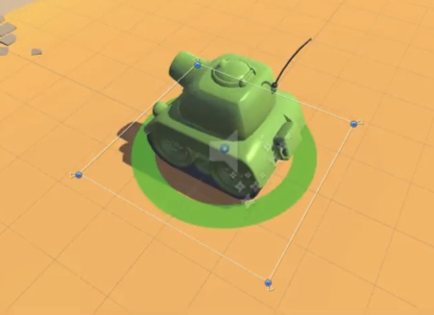

**Figure 3.6.** A screenshot of Tank health wheel

In addition, there is a Image type at the corner, select Left that the health slider work as LOL or other famous competitive games. What's more, when the shooter died, the shooter should be explosion and has a audio. So, in the hierarchy we need to create AudioSource as a component and set every sound files.

To make our work eary, we can go through a Tanks game tutorial [6]. that is health slider what we want to create. In addition, shooter game can follows the Tutorial in the offical website TankTutorialSlideDeck-v1.pdf from page 78 to 92.

Save the scene.

## 3.7 Shell creation and firing

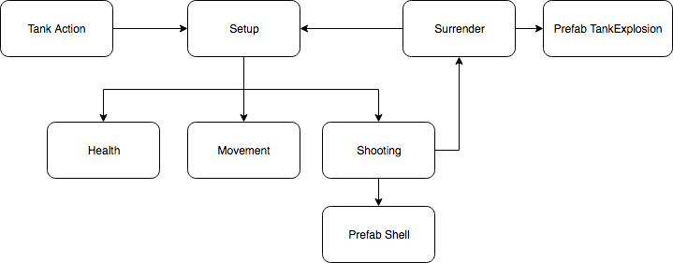

**Figure 3.7.** The Mechanism of Tank Action

As normal player know, tank can generate shells and shell can explore and damage tank. According to this normal phenomenon, project add several components to tank and shell. After create a tankShooting.cs, we need to upload file to tank prefab like figure below.

Inside the figure, tank has health, tank can move, tank can shoot.

The shooting because it can instantiate shells.

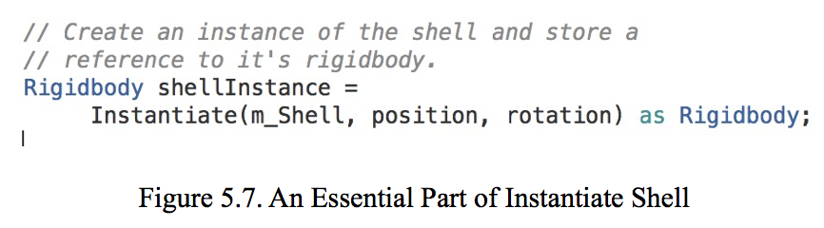

The code above is an example of how tank can instantiate shell. Which prefab is going to instantiate, where the shell comes and what angle the shell goes.

Then, check the option Is Trigger and set Direction to Z on component Capsule Collider. Rigidbody and AudioSourcec components should be similar as shooter creation. Also, set a shooter public variable to player.

Which is used to let this lobby know this tank can spawn at the start of game.

Network manager creates need to add component network manager& network manager HUD, this network manager is used to identify the component network identity. This network manager HUD is used to identify the network transform. So, each prefab can move or change have to be added component network identity and network transform.

Here is several step of create network shell creation and firing.

1. create a GameObject as a networkmanager. Add component network manager& network manager HUD.

2. Create network identity &network transform (sync transform) & Tankshooting script (net version) in tank prefab

3. Create network identity & network transform (sync transform) & shellController script (net version) in shell prefab /spawnable object in networkmanager

### How shell damage tank health?

There should be 3 main steps and many detail need to deal with. 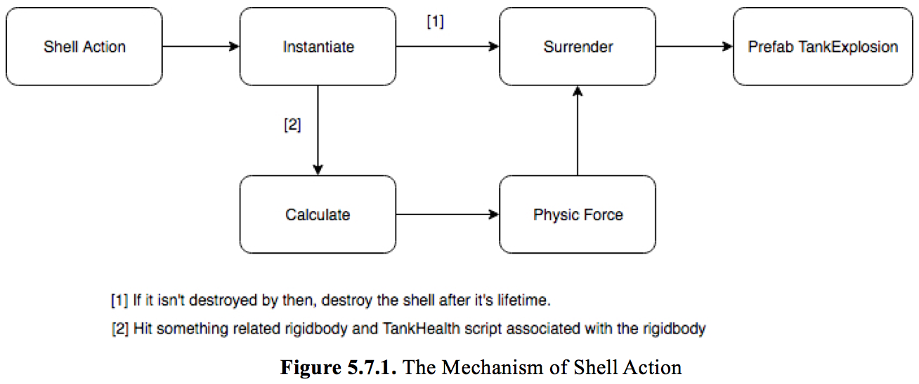

##### Find hit rigidbody related

Go through all the colliders and find their rigidbody. Detail below.

If they don't have a rigidbody, go on to the next collider.

If they have a rigidbody, find the TankHealth script associated with the rigidbody. If there is no TankHealth script attached to the gameobject, go on to the next collider.

##### Create a vector to deal with the distance

Create a vector from the shell to the target.

Calculate the distance from the shell to the target.

Calculate the proportion of the maximum distance (the explosionRadius) the target is away.

#### Calculate the damage according to distance

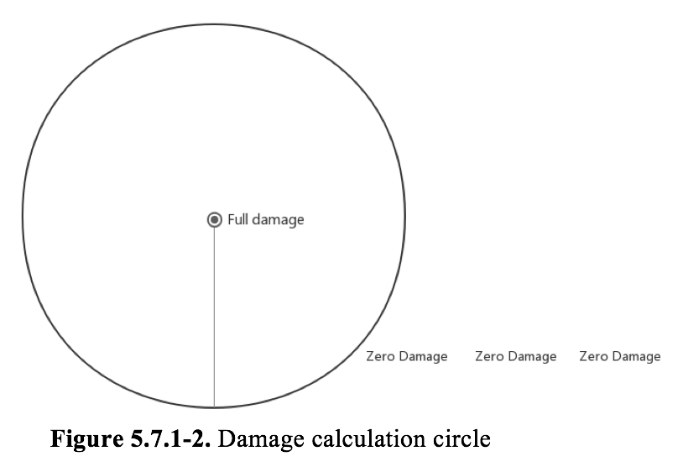Calculate damage as this proportion of the maximum possible damage. Reduce current health by the amount of damage done.

If the current health is at or below zero and it has not yet been registered, call OnZeroHealth.

ONLY perfectly hit can get the full damage and destroy tank with only one shoot.

#### Other

Make sure that the minimum damage is always 0.

Deal this damage to the tank.

### How shell makes tank physic forces?

#### Find hit rigidbody related

Collect all the colliders in a sphere from the shell's current position to a radius of the explosion radius.

  Go through all the colliders and find theirs rigidbody

  If they don't have a rigidbody or we don't own that object, go on to the next collider.

#### Deal with the physic force

Add an explosion force with no vertical bias.

## 3.8 Joysticks

In this project, joystick is a virtual input device consisting of a stick. This stick can report the angle and distance to the center.

the reason why project select two joysticks is in the mobile game, player cannot control the tank in keyboard or crossplatforminput. The only thing player can touch is screen. So, the bridge between screen and game is joystick.

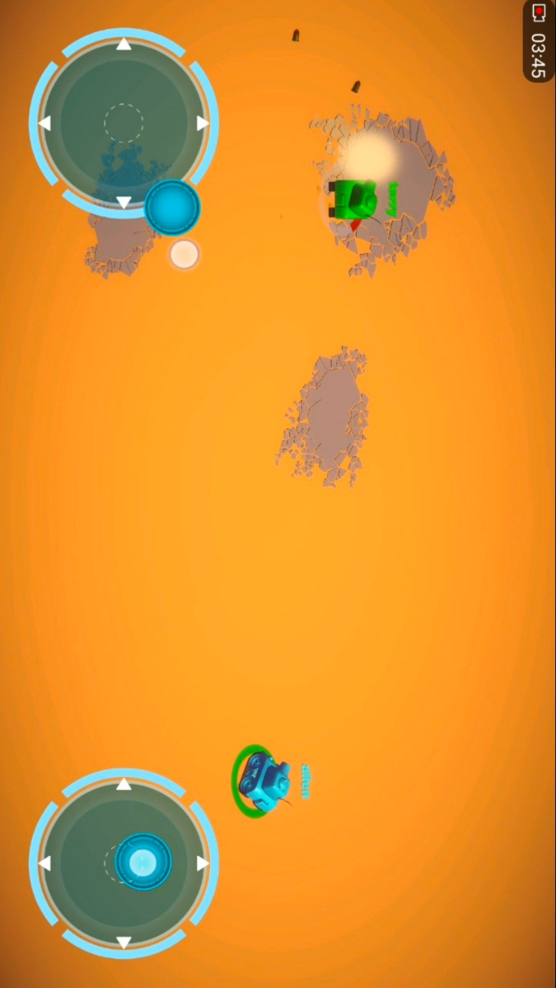

**Figure 3.8-1.** A Screenshot of Joysticks

For the game scene, like the screenshot below, left joystick is using to control the tank, right joystick is using to control the shooting.

The mechanism of movement joystick and shooting joystick is not same.

### Movement Joystick

**Figure 5.8-2.** Mechanism of Movement joystick



There are two different position the joystick current has. One is joystick does not move, the other one is joystick moves. When joystick does not move, the position of major character is sample, which just need to play the static animation. If the joystick moves, the position is much more complicated. The joystick need to create a vector associates the center of joystick coordinates. Then set for the angle currently major toward. Then move the major character with play the moving animation.

### Shooting Joystick

There are two different position the shooting joystick current has. One is joystick does not move, the other one is joystick moves. When joystick does not move, play the static animation like the movement joystick. If the joystick moves, the shooting joystick need to create a vector associates the center of joystick coordinates. Then set for the angle currently mouse of major character toward. Then shoots from the major character with generate shell prefab.



**Figure 3.8-3.** Mechanism of Shooting joystick

## 3.9 Game managers & multiple-player establishment

In this part, game managers are creating a game rule. Which is about how to win a game and decide the winner.

Any multi-player game needs to implement 2 broad spheres of function. And allow players to connect to those sessions. Once two players are connected, turn the traffic routed toward available and uses Round Robin method in starting position can get rid of a large amount of trouble. We need to receive and send data from other instances devices.

Finally, save the scene. Then the entire game is complete. Go on have fun!

# References

[1]"Unity - Unity - Overview", Unity, 2017. [Online]. Available: https://unity3d.com/unity. [Accessed: 10- Jun- 2017]

[2]"Unity3d就业前景怎么样？工作好找吗？", Sohu.com, 2017. [Online]. Available: http://www.sohu.com/a/129947117_252502. [Accessed: 11- Jun- 2017].

[3]"Lara Croft GO | Made with Unity", Made with Unity, 2017. [Online]. Available: https://madewith.unity.com/en/games/lara-croft-go?_ga=2.66045934.1926479982.1494921971-954352829.1491021222. [Accessed: 10- Jun- 2017].

 [4]"Jenny LeClue - Detectivú | Made with Unity", Made with Unity, 2017. [Online]. Available: https://madewith.unity.com/en/games/jenny-leclue-detectivu?_ga=2.27652092.1926479982.1494921. [Accessed: 10- Jun- 2017].

[5]"珍妮的线索攻略", Youba.com, 2017. [Online]. Available: http://www.youba.com/zixun/97464/1.htm. [Accessed: 10- Jun- 2017].

[6]"TanksTutorialSlideDeck-v1", Oc.unity3d.com, 2017. [Online]. Available: https://oc.unity3d.com/index.php/s/n6P1VcTa4NWQbyn?_ga=2.175456482.1744239074.1494930459-954352829.1491021222. [Accessed: 10- Jun- 2017].

[7]"英雄联盟综合资讯", Lol.qq.com, 2017. [Online]. Available: http://lol.qq.com/v2/. [Accessed: 10- Jun- 2017].

# Appendix



## 1. Sample code

TankShooting.cs is the essental code part of this project. Here is the screenshot of my Tank Shooting.

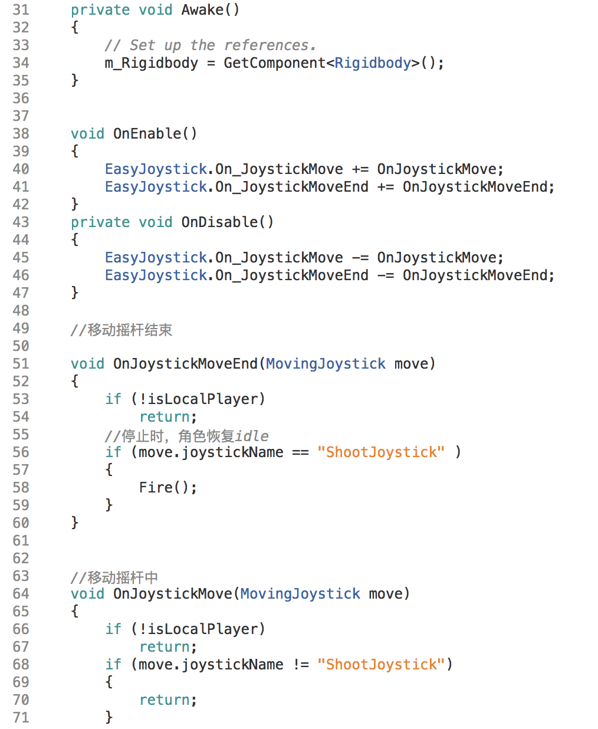

Figure 1: Joystick Awake & OnEnable & OnDisable

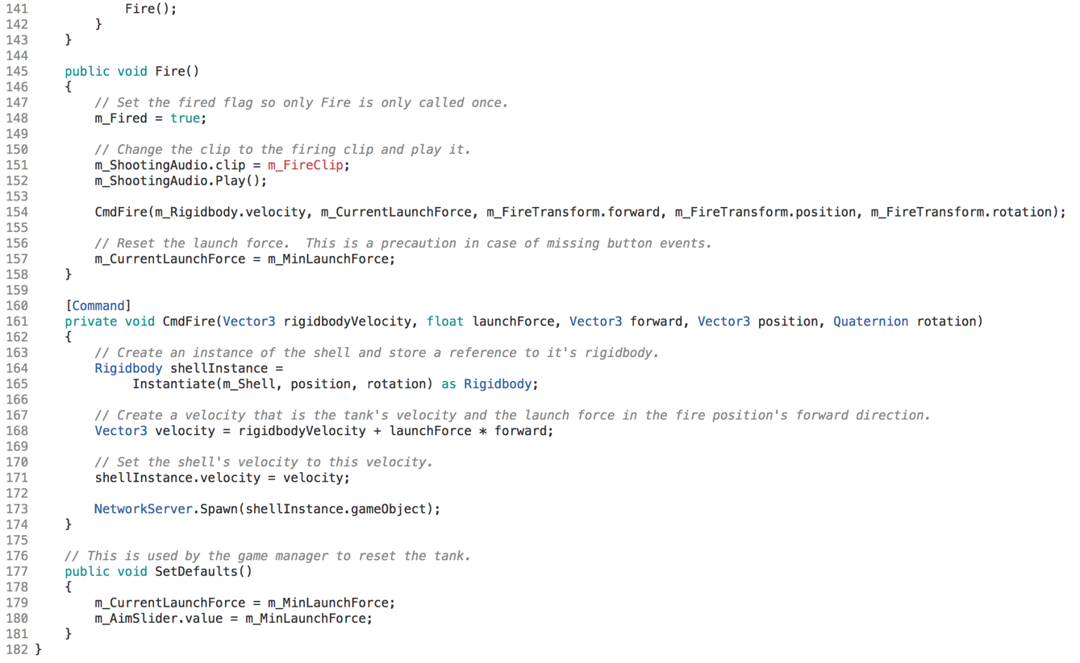

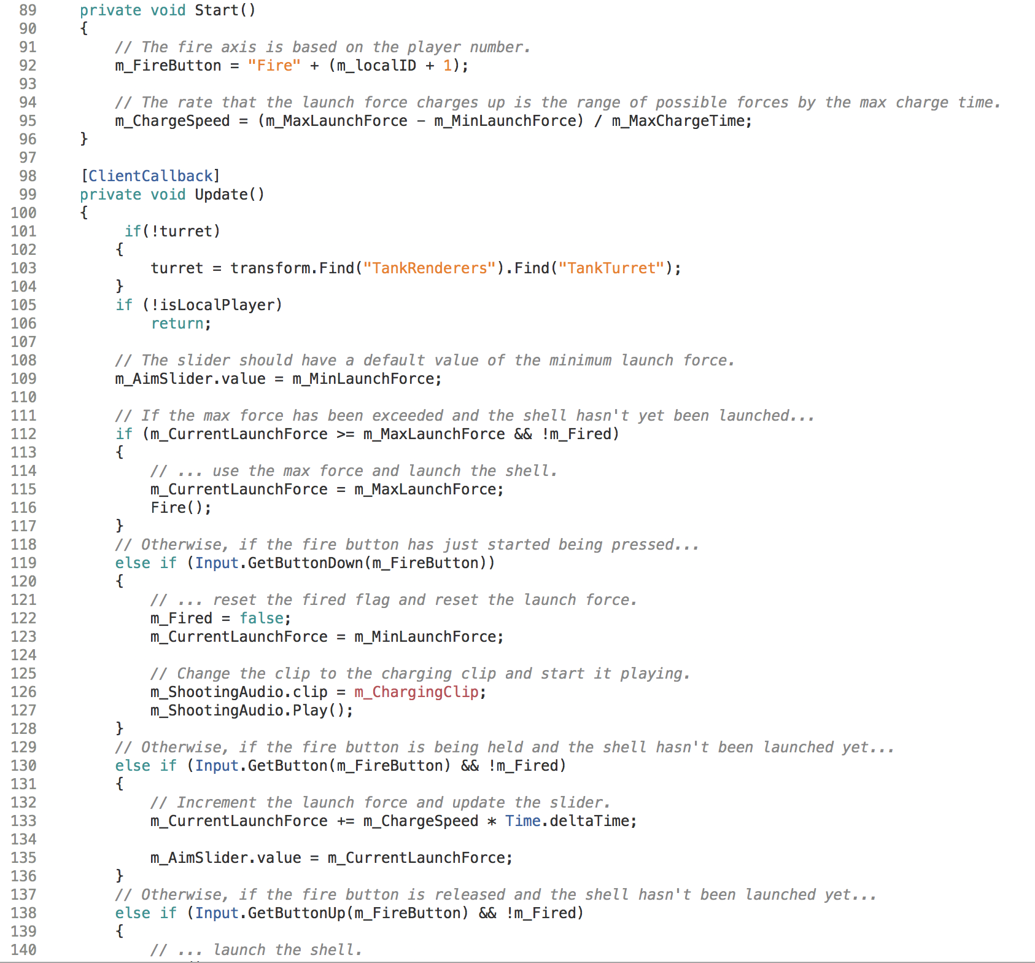

Figure 2: Deal with CrossPlatfromInput

Figure 3: Fire Function

## 2. Shell creation and firing (deleted)

Firstly, we have to create a shell as a model. and open it on the hierarchy as a GameObject. Then, check the option Is Trigger and set Direction to Z on component Capsule Collider. similar as shooter creation.

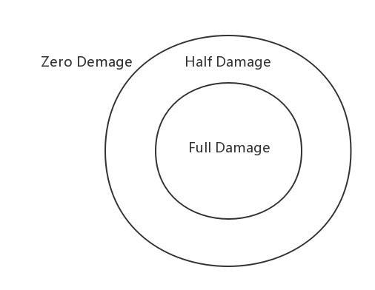

**Figure 7.3.** Damage calculation circle

Also, set a shooter public variable to player.

Most important of the shells part is when the shell aim at directly to the shooter, the shooter shut down immediately. if the shell does not aim at the shooter but shell explodes next to the shooter, the shooter may suffer from some of the damage but don't shut down, which is a overlap sphere. once the shooter is out of the overlap sphere, that shell will not gives any damage to shooter.

## 3. Skybox (deleted)

There is a load level component in the bottom inspector. When we install the NGUI environment we can directly use the component which can jump the scene from 1 to 2 by click on bottom. This is the most important technology in creating menu. By doing this, we can select the map inside the game instead of quit. In addition, I got a good skybox in the map, it can move and rotate follow the player. It should set the camera in the center of the prefab circle and ask the camera always follow the player. Which look like a sky. Also, in the prefab inspector, there are skybox_material file using to rotate and move. 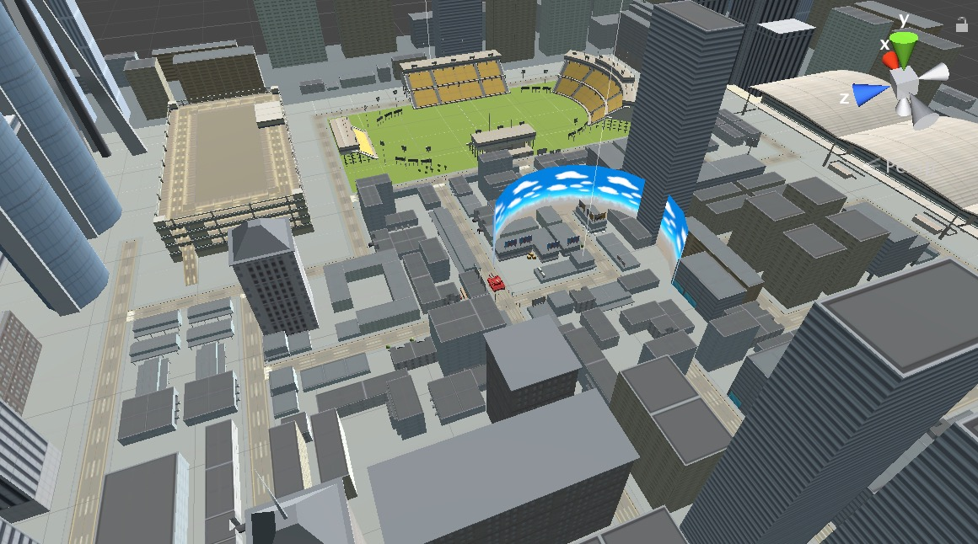

**Figure 0.1.** skybox screenshot